This is happening…
as of 4/1/22

Although NOLA has lifted vax and masks requirements, several venues are still requiring proof of vaccines and masks. Please play it safe and be sure to bring your proof of vax and fashionable face wear.
Also, we are still asking for the health and welfare of all our guests and the general public,
please be sure to test negative for Covid-19, at the most, 48 hours before you travel to New Orleans.

Here is an updated list of planned events for April 11 – 15.
Events in GREEN indicate birthday celebrations we hope you’ll attend as our guests.
PLEASE, NO PRESENTS. YOU ARE THE GIFT!
All other events are absolutely optional and for your consideration.
Also listed are additional suggestions and recommended things to do
and sights to see while you’re out and about on your own.

Latest revisions/additions to this ever-changing list of events will be in PURPLE
Events are subject to last minute changes so make sure I have your cell #
in case I have to text you.
If your plans change, no prob, just let us know.

IMPORTANT: we urge you to please take a cab or Uber to any events outside the French Quarter, especially anytime at night. Also, please buddy up with others who may be staying near you.
A map of guest hotels is included at the end of this document.

Birthday headquarters: Treme Blue House, 1210 N. Galvez
Any questions about anything, don’t hesitate to call or text Patti - 510.407.9174
Monday, April 11:
9am – Breakfast
Degas House, 2306 Esplanade, Treme
Rise early and enjoy an authentic Creole breakfast at the former home of French Impressionist, Edgar Degas. Menu $35 (Patti, Mark, Marlee & Neil confirmed)

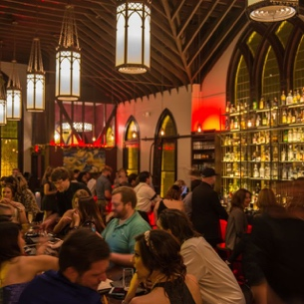
7:30PM = Dinner + Hello! (change in venue since Sylvain couldn’t take us all!)
Vessel, 3835 Iberville (just steps from the Canal St. trolly Scott St. stop)
Let’s head mid-city to a neighborhood gem located in an iconic 100-year old Lutheran church. Not only an award-winning restaurant and bar, but a beautiful architectural setting where each cocktail is served in a unique glass because, “the finest libations should be served in the proper vessel.” My kind of place.
Disclaimer: we are sitting inside because, well, look at it! Menu $$
Who’s coming: Patti, Mark, Mary, Jim, Patty, Michael, Marlee, Neil, Ron, Rosie, Elma, Erin, Ellen +2
If your name is missing OR you are NOT joining us, please let me know asap.

Tuesday, April 12:
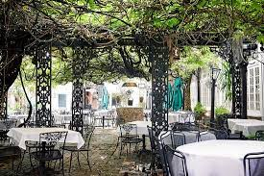
I won’t be able to attend, after all, as I’ll be setting up for the pool party, but please do try to go. Reservations suggested.
Brunch – 10am
Court of Two Sisters, 613 Royal St.
Built in 1832, this Creole landmark boasts the largest courtyard in the city. The restaurant is named for the two sisters whose downstairs shop outfitted many of the city’s finest women with Mardi Gras costumes and offered perfumes from Paris. The front gates were wrought in Spain especially for the restaurant and legend has it that Queen Isabella had them blessed so that their charm would pass on to anyone who touched them. Oh, yeah…come hungry. The buffet is amazing. Menu $33/per person

3:30pm – 4:15, Porch Testin’ Pre-pre-party
Treme Blue House, 1210 N. Galvez
For the safety of all our guests, you’ll need to take a negative Covid-19 antigen rapid test (tests provided + one adult beverage while you wait) before entering the Treme Blue House. Sorry, no exceptions. We hope you understand and appreciate these extra precautions.
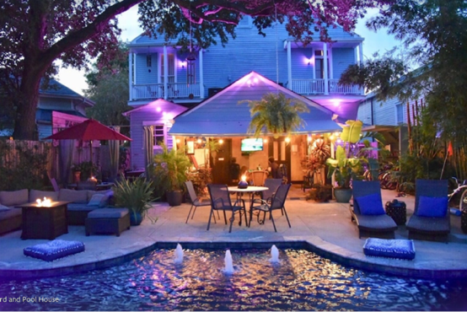
4:00pm - Pool Party!!
Treme Blue House, 1210 N. Galvez
Bring your swimsuit and dancing shoes and hang out at birthday headquarters for some great music, food, drink and general hoopla!! Come hungry and enjoy a delicious spread from Willie Mae’s, & fabulous birfday cake!

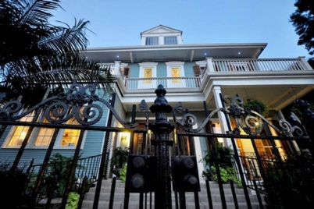
5:30 pm – Presentation: Welcome to New Orleans!
Treme Blue House, 1210 N. Galvez
Arthur Morgan Smith, former Communications Director at the Louisiana State Museum, tour guide and volunteer for Save Our Cemeteries and Friends of the Cabildo, will give a fun and informative presentation on the history and culture of this amazing city and is happy to answer any questions you may have. Don’t miss it!

If you’re brave, stick around for…

8:30pm – Dark History by the Fire

Hosted by local legend, Jonathan Weiss, one of the South’s leading historians and purveyors of the macabre history that makes New Orleans the most haunted city in America.

Wednesday, April 13 (NONOTSIXTY!?!)

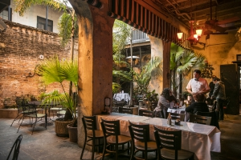
6:30 PM – Creole Nibbles & Cocktails
Napoleon House (bar/restaurant), 500 Charters (x. St. Louis)
This two-hundred-year-old landmark was intended to be used by the original owner to shelter the exiled Napoleon and Josephine, but alas, the emperor never made it to the New World. European ambience, signature Pimm’s Cups and Muffuletta sandwiches – an homage to the Italian immigrants who first opened grocery and deli stores along the riverfront of the French Market.
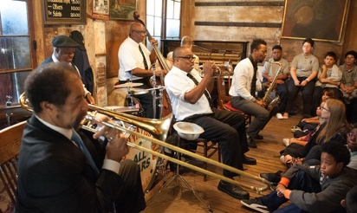
8:15PM (sharp!)– Preservation Hall Jazz Band
Preservation Hall, 726 St. Peters, French Quarter
Originally opened in the 1950s as an art gallery, this intimate, funky venue presents acoustic New Orleans Jazz concerts featuring ensembles from a current collective of 50+ local master players. On any given night, audiences bear joyful witness to the evolution of this venerable and living tradition. Put some $$ in the tip jar and make a request!

9:30pm – Party with pirates!
We’ll be taking a short stroll to historic Pirates Alley, in the heart of the Vieux Carre, the short cut where pirates may (or may not) have used to get from the river to Lafitte’s Blacksmith Shop to barter their booty. What is true is that William Faulkner lived at #625 and wrote his first novel, Soldier’s Pay, on this very street. We’ll be drinking (and eating, if you like) at Pirate’s Alley Café and Absinthe House, 622 Pirates Alley, of course!

11pm – For the serious late-nighters
Lafitte’s Blacksmith Shop, 941 Bourbon (see Seriously Spooky below)
Hang with the ghosts of pirates…and maybe…see Jonathan, again!?

Thursday, April 14

4pm (sharp!) – Get your Gris-Gris On! (my treat)
Voodoo Authentica, 612 Rue Dumaine (see Do You Do Voodoo? below)
Meet me out front and we’ll visit the shop/museum and get our personal gris-gris bags, including a personal blessing from Mambo Juneaux, spiritual consultant. Who’s coming: Patti, Patty, Mary, Elma, Erin, Ellen, Mo, Tricia, Michele, Kari. If you do not see your name on this list and want to join us, give me a holla.

6pm til 9PM – Cooking
New Orleans School of Cooking – 524 St. Louis, French Quarter
Let’s make our own dinner, drink a little and be entertained by our chef instructor. Private class.
1 SPOT STILL AVAILABLE! Contact me ASAP if you want to join us. Vegan & gluten-free substitutions available.

9:30 til who knows when - Meeting of the International Ultimate & Bestest Queen Aficionados
The Dungeon, 738 Toulouse Street (see the Poop on Bourbon Street below)
(although all are welcome – please wear something to make Freddie proud!)

Friday, April 15
4:00pm – Very Happy Hour or Two
Bacchanal Fine Wine & Spirits, 900 Poland Ave.
This “funky, arty” Bywater neighborhood hangout is “an experience laboratory where food, music & culture collude with Holy Vino to create the most unique evenings you will ever experience.”
A very chill spot for a warm, lazy afternoon. Sample menu.

So much more to see & do…
Best to make sure this info is still up-to-date before you head out.
Important: don’t forget your masks and proof of vaccines.

Notable Notables in the Garden District (make time to go, if you can)

NOLA is home and has been home to some interesting people and has been the location for too many films to list. If you’re out tooling around the Garden District looking at all the historic houses, here are some fab ones of note, all within 10 minute walking distance:
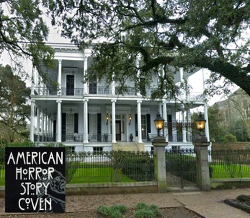
Fans might recognize 1410 Jackson Avenue, - the Buckner Mansion built in 1956, as Miss Robichaux’s Academy for Exceptional Young Ladies from American Horror Story: Coven. One of the most photographed houses in New Orleans.

Although she owned several properties around the city, the Greek Revival-Italianate mansion at 1239 1st Street was the home of vampire writer, Anne Rice, until 2004 and is where she penned many of her novels, including her most famous, Interview With the Vampire.

2425 Coliseum Street – built in 1850, this “Gothic Victorian” is the former home of Trent Reznor of Nine Inch Nails who lived here for ten years. The home appealed to him, apparently, because of the unique bone-like columns that surround the house. It is now the home of actor, John Goodman.

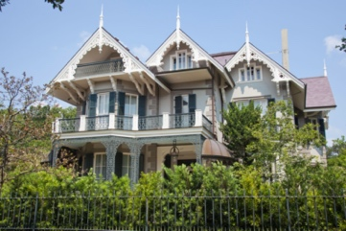
Known as the Koch-Mays House, the Swiss Chalet House, and Freret’s Folly, this beauty at 2527 Coliseum is resplendent with period details, like intricate ironwork and heavy gilded interiors. Since 2009, it is also the home of actor, Sandra Bullock. The house is conveniently located around the corner from the famous restaurant, Commander’s Palace.
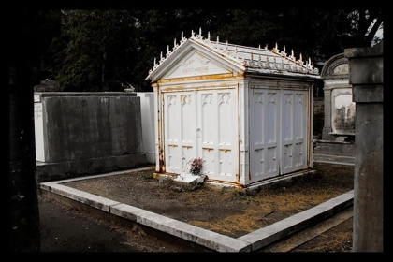
Also just around the corner (Sandra is so Goth!) is Lafayette Cemetery No. 1., at 1427 Washington founded in 1833, the location for scenes from Easy Rider and home of Lestat’s tomb from Interview With the Vampire. I believe this is one of the only cemeteries still open to visitors.
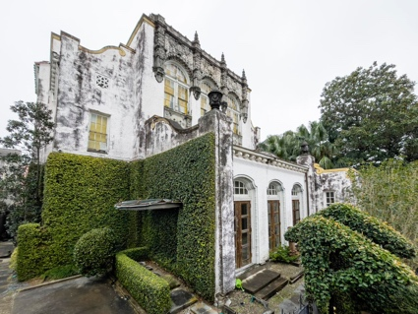
About five blocks away, go check out the mysterious, La Casa de Castille at 1527 Harmony Street. Built in 1927, this cool church-turned-ballet-school-turned-mansion-to-Beyoncé caught fire (mysteriously) in 2021 and has been the source of much gossip ever since. The Baroque architecture is fantastic and worth a look-see and apparently there’s a roof-top garden.

The Poop on Bourbon Street

As you most likely know, the reputation of Bourbon Street mainly revolves around garish trinket shops and drunk, unruly college kids and convention-goers getting their ya-yas out, hoping to catch a glimpse of some nakedness. For these reasons (and possibly more) you might want to avoid Rue Bourbon at all costs. That said, there are actually a few places on the crowded, rowdy row that are worth checking out.

Old Absinthe House, #240 – cross street Bienville
Open seven days a week – generally from 9am til 2am (4am on Sundays!)
This iconic corner spot is perfect for grabbing a stool, sitting back and watching the wild and whacky show that is Bourbon Street go by. Marvel at the shenanigans while you sip on a refreshment, perhaps their signature Absinthe Frappe, in this cool building that dates back to the early 1800s.

The Dungeon – just off Bourbon at #738 Toulouse
Opened in 1969, The Dungeon bar is still today the rock ‘n roll scene of New Orleans. This dark, intriguing spot down at the end of an eerie side alley was built on a reputation as a hangout for vampires and rock stars, including Kiss, Queen, ZZ Top, to name a few. Apparently, Brian May of Queen wrote Now I’m Here (Queen at their coolest. Yes, the video is dark during the intro) after meeting a “lady” at the bar and falling in love, hence the line in the song, “Down in the Dungeon just Peaches and me.”
I think it’s safe to say, Freddie was here! Oh, yeah…and Roger and John…and Ratty…

Fritzel’s European Jazz Club, #733 – between Orleans & St. Ann
Open daily, 11am til ?
Situated in an historic 1831 building in the heart of the French Quarter, since opening in 1969, Fritzel’s has become a mecca for jazz lovers and musicians alike. Home of traditional New Orleans jazz every day and night of the week.

Oz New Orleans, #800 – cross street St. Ann
Open 6pm til ?
Infamous, late-night gay dance club with DJs, drag shows, go-go dancers & a balcony for people-watching. Not for the faint of heart.

Clover Grill, #900 – cross street Dumaine
Open 24 hours!!
As seen in The Curious Case of Benjamin Button, this retro diner has been serving the “best burgers and breakfasts on Bourbon Street since 1939.” Their motto – “We love to fry and it shows.”

Lafitte’s Blacksmith Shop (bar) – #941 (see Seriously Spooky section below)
History Matters

New Orleans Jazz Museum, Old Mint Building, 400 Esplanade, French Quarter
Tues – Sun, 9am – 4PM, $8
Celebrates the history of jazz, in all its forms, through dynamic interactive exhibits, multi-generational educational programming, research facilities, and engaging musical performances. Explore America’s quintessential musical art form in the city where jazz was born.

Hermann-Grima + Gallier Historic Houses, 1132 Royal St, French Quarter
Wed – Mon, 10Am-4PM, $25 for both homes
Nothing tells a story like a home. Touring these two 19th-century homes provides an accurate and inclusive illustration of the historical fabric of New Orleans. HGGHH continually works to expand their interpretation of both houses, including the lives of the enslaved peoples, who both lived and worked there.

National WWII Museum of New Orleans, 945 Magazine St.
Open daily 9AM – 5PM
Award-winning museum featuring many special events, tours and lectures, tells the story of the American experience in the war that changed the world—why it was fought, how it was won, and what it means today—“so that all generations will understand the price of freedom and be inspired by what they learn.”

Art For All

Royal Street Stroll
Take time for a leisurely walk down the most elegant street in the French Quarter. Royal street is lined by a wide array of interesting, funky and exquisite art galleries, antique shops and a gorgeous, historic hotel. Start at the east end and work your way down towards Canal St. There are dozens places worth stopping to see. Here is just a sampling:
* An artist after my own heart - Frank Relle Photography at #910 is some of the most hauntingly gorgeous work you’ll ever see. Check out the video on his website to see how he works. Amazing.
* Stroll around Jackson Square, where artists gather to sell their wares all around the park, then pop into the Rodrigue Studio at #730 Royal to see what the famous Blue Dog has been up to.
* At #622 Royal you’ll find the world-famous M.S. Rau antique and fine art gallery, established in 1912 with 40,000-square-feet of carefully selected works from a diverse array of artists and makers who have defined the fine and decorative arts over the centuries, including Monet, Rembrandt & Chippendale, to name just a few. The collection is breathtaking.
* For fans of architecture and fashion, The Historic New Orleans Collection at #520, is a museum dedicated to the preservation of the culture of NOLA, featuring restored historic buildings and exhibits.
* Cap off your stroll with a delicious cocktail at the fun Carousel Bar inside the gorgeous Hotel Monteleone at #214. Kitschy and wonderful!

Mardi Gras World, 1380 Port of New Orleans Place
Open daily 9AM – last admission 4:30PM, $22

Yes, it’s touristy, but, if you are a maker, artist or craftsperson of any kind – you really should check out this amazing, one-of-a-kind working museum. See where and how the huge, lavish floats are made, over 500 every year, and hang out where it’s Mardi Gras every day! Learn about founder Blaine Kern and the rich history of Kern Studios that date back to 1932, when the first mule-drawn float was built on the back of a garbage wagon. This massive space is a feast for the senses. To get there, catch a free shuttle from many of the hotels on Canal St.

New Orleans Museum of Art, One Collins C. Diboll Circle, City Park
Open Tues – Sunday, 10AM – 5PM, $15
Sculpture Garden open daily, 10AM – 5PM, Free
Catch the Canal/City Park streetcar up to the park and see more art! A walk through the sculpture garden is a peaceful respite from the hustle of the FQ.

Do You Voodoo?

Voodoo (or Vodou, Vodun, Vaudou), an Afro-Haitian religion, arose through a process of syncretism between the traditional religions of West Africa, the Roman Catholic form of Christianity, and Haitian Vodou. In Louisiana, Voodoo was heavily practiced from the 18th century to the early 20th century, by which point it had effectively died out, only to be revived in an altered, more commercial form in the late 20th century. No central authority is in control of Louisiana Voodoo, which is organized through autonomous groups and, like all religions, it has its pros and cons. Although you may encounter lots of “voodoo” shops and trinkets in the French Quarter, true believers of the religion adhere to the secretive nature of its practices. Still, it is part of the history of New Orleans and it can be interesting to take a peek at what the city has on offer…

Voodoo Authentica, 612 Dumaine
Open everyday, 11am til 7pm
Cultural Center & Collection is a Practitioner-owned and operated establishment, founded in 1996, providing hand-made, unique New Orleans, Haitian and African spiritual arts & crafts.

Bloody Mary’s Haunted Museum & Spirit Shop, 828 N. Rampart St.
Call for hours 504.915.7774
Wander through Paranormal displays and come spirit shop in the Voodoo Pharmacy to get your personal metaphysical prescription filled! Explore the voodoo occult Paranormal Haunted museum & hear the haunted history behind New Orleans Ghosts on your visit. Museum tours by day ghost hunts by night! Come see a haunted collection, haunted dolls, Victorian Séance parlor, ghost photo gallery, Occult artifacts, Voodoo Altars all in a 200-year-old haunted house in a historic French Quarter complex.
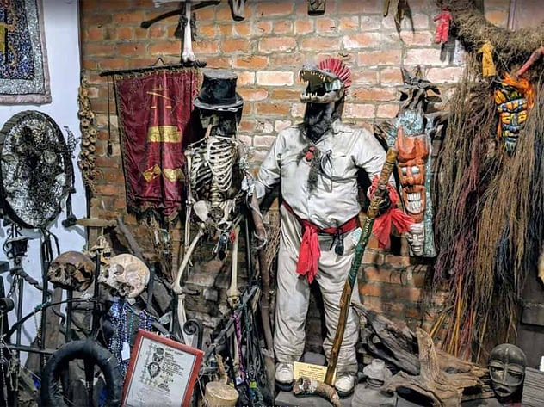
New Orleans Historic Voodoo Museum, 724 Dumaine St.
Open 7 days a week, 10am til 6pm, $10
Serving the New Orleans community since 1972 and bringing you a casual and curious experience intended to preserve the legacy of New Orleans' Voodoo history and culture while educating and entertaining visitors

Seriously Spooky
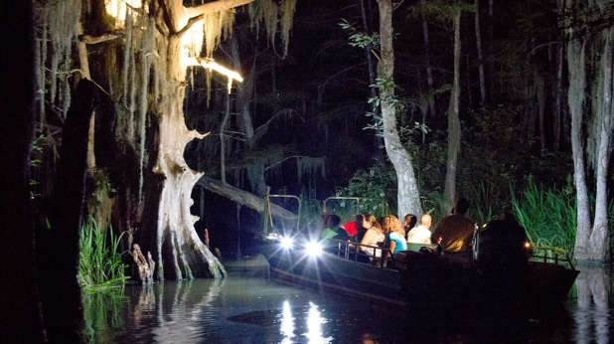
Honey Island Swamp Tour – at night!
7 days a week, 5PM $59
Forget the all the ghost and vampire business – nothing is quite as creepy as floating through the swamp as the sun sets and the wildlife comes out to play. Cajun Encounters is a proud member of the Louisiana Nature Conservancy, and works with a responsibility to protect the environment, providing an intimate look at the swamp without impacting the grasslands or the many diverse species of animals that call the swamp home: alligators, wild boar, raccoons, snakes, owls, egrets and more – all in their natural habitat, and just a few feet from your boat!
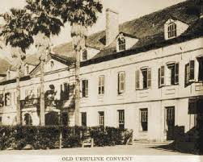
Old Ursuline Convent, 1100 Chartres Street
Museum – Thurs, Fri, Sat, Mon – 10am last admission 1:15pm
Built in 1727 and founded by the Ursuline nuns of Rouen, France. The convent served as a hospital and orphanage for young girls sent over from France by the King to the new colony, as future brides for the unruly, single frontiersmen who populated the wild city. Arriving in 1728, the poor girls disembarked at the port of New Orleans in the dead of night, pale and unwell after the journey that was supposed to take three months ended up taking five. They became known as the “casquette” girls, named so because of their pale, sickly condition, and the little casket-shaped boxes they brought with them to carry their meager possessions. Folklore has it that’s not all the girls brought over with them from France. Arriving in the dead of night? Pale? Caskets? When the nuns quarantined the young girls on the third floor of the convent (supposedly even nailing the window shutters closed with nails blessed by the Pope!), word spread the “casquette” girls were actually….can you guess?? Vampires, of course!! Decedents of these girls live on in New Orleans today….

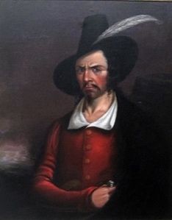
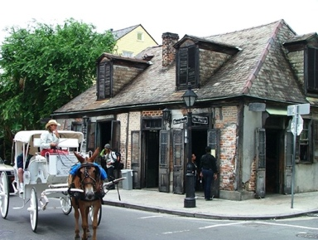
Lafitte’s Blacksmith Shop (bar) – 941 Bourbon Street
Open every day Noon til ??
Most likely built as a house in the 1770s during the Spanish colonial period, Lafitte’s is one of the oldest surviving structures in New Orleans. According to legend, French pirate, Jean Lafitte (1780 – 1823), owned a business here with his brother, Pierre, a blacksmith in the early 19th century. Together, they likely used the structure to plot illegal seizures and the sales of contraband. You know, pirate stuff! More recently, the café/bar became a popular night spot that attracted a bohemian clientele, including celebrities like Noël Coward and Tennessee Williams. It was declared a National Historic Landmark in 1970 and is said to be one of most haunted spots in the French Quarter.

Cemeteries

The Historic Cemeteries of New Orleans are a group of forty-two cemeteries that are culturally significant. These are distinct from most cemeteries commonly located in the United States in that they are an amalgam of the French, Spanish, and Caribbean historical influences on the city of New Orleans in addition to limitations resulting from the city's high water table. The cemeteries reflect the ethnic, religious, and socio-economic heritages of the city. Architecturally, they are predominantly above ground tombs, family tombs, civic association tombs, and wall vaults, due to the high water table in the soil. If a body or coffin is placed in an in-ground tomb in New Orleans, there is risk of it being water-logged or even displaced from the ground. Cemeteries are often in neo-classical design and laid out in regular patterns similar to city streets. They are referred to colloquially as “Cities of the Dead”, coined by Mark Twain, they say.

Lafayette Cemetery #1 is supposedly the resting place of Voodoo Queen, Marie Laveau, and the future resting place of Nicholas Cage (you can see his pyramid monument from the street). Unfortunately, this cemetery is now closed to the public until future notice due to wear and tear and vandalism. St. Roch #1, is also closed for restoration, apparently. A very cool place where I saw the premiere of the Blair Witch Project projected onto one of the walls.

Luckily, it looks like my favorite (double check to make sure) is open:
Lafayette Cemetery #2, 2110 Washington St. in the Garden District (across from Commanders Palace and around the corner from Sandra Bullock’s house) is open from 8am til 2pm.
Questions? Be sure to ask our “Welcome to New Orleans” speaker, Arthur and/or our “Dark History” speaker, Jonathan, at the pool party! They know allllllll about ‘em.

Slow Your Roll

St. Charles Streetcar (Also see Notable Notables above)
Take it easy…catch the streetcar at the Common St. stop (off Canal) and let the iconic green trolly putt-putt you westward, through several NOLA neighborhoods. See the CBD (Central Business District), Warehouse/Arts District, Irish Channel, Garden District and Uptown, all from the comfort of your 150 year-old wooden bench. For $1.25 (exact change needed) you can sit back and enjoy the city as it rolls by. The grandeur of the historic Antebellum homes is not to be missed and if you’re lucky, you’ll catch the school kids playing their horns and drums as they walk to and from school. Magical. Get off at Tulane University and cross the street to visit Audubon Park for a stroll among the weeping willows OR hop off where St. Charles St. bends into S. Carrollton and treat yourself to a milkshake at the Camellia Grill. When you’re ready, hop back on the streetcar heading east toward Canal St., pay another $1.25 and see what you missed on the way up!

Off the Beaten Path…

Explore the Lower 9th Ward – The recent tornado did blow through part of this historic neighborhood. Please be mindful of any visit there and check first to see what is open.
You may have heard of this important neighborhood but unfortunately, possibly for all the wrong reasons. This section of the city was arguably the hardest hit in August of 2005, a.k.a. Katrina, and has been the slowest to recover. Deeply rich in culture but economically almost forgotten, the Lower 9th Ward (“lower” because it’s further down the Mississippi River and “ward” being an outdated name for voting precincts) has given New Orleans some of its most honored traditions and prized citizens including Fats Domino and Jon Batiste. Use this map as your guide and if you have time, make an appointment to stop into the museum, House of Dance and Feathers, located in the backyard of director and curator, Ronald Lewis. The museum is free and you’ll get a history lesson that is priceless!

Bike the Bywater
Ride along Crescent Park on the banks of the Mississippi River to this neighborhood (past the French Quarter, around the bend from the Marigny) that has become a “hipster” paradise pretty much since the Bacchanal Wine & Spirits (dubbed “NOLA’s backyard party”) opened just after the flood of 2005. Musicbox Village and Beanlandia (an organization I support) are two very wonderful art spaces/organization worth a look-see.

Where everybody’s at:

We kindly urge you to please take a cab or Uber/Lyft
when you travel outside the Quarter, especially at night, and please
use the buddy-system to share rides when possible.

Treme Blue House
1210 N. Galvez
Patti & Mark
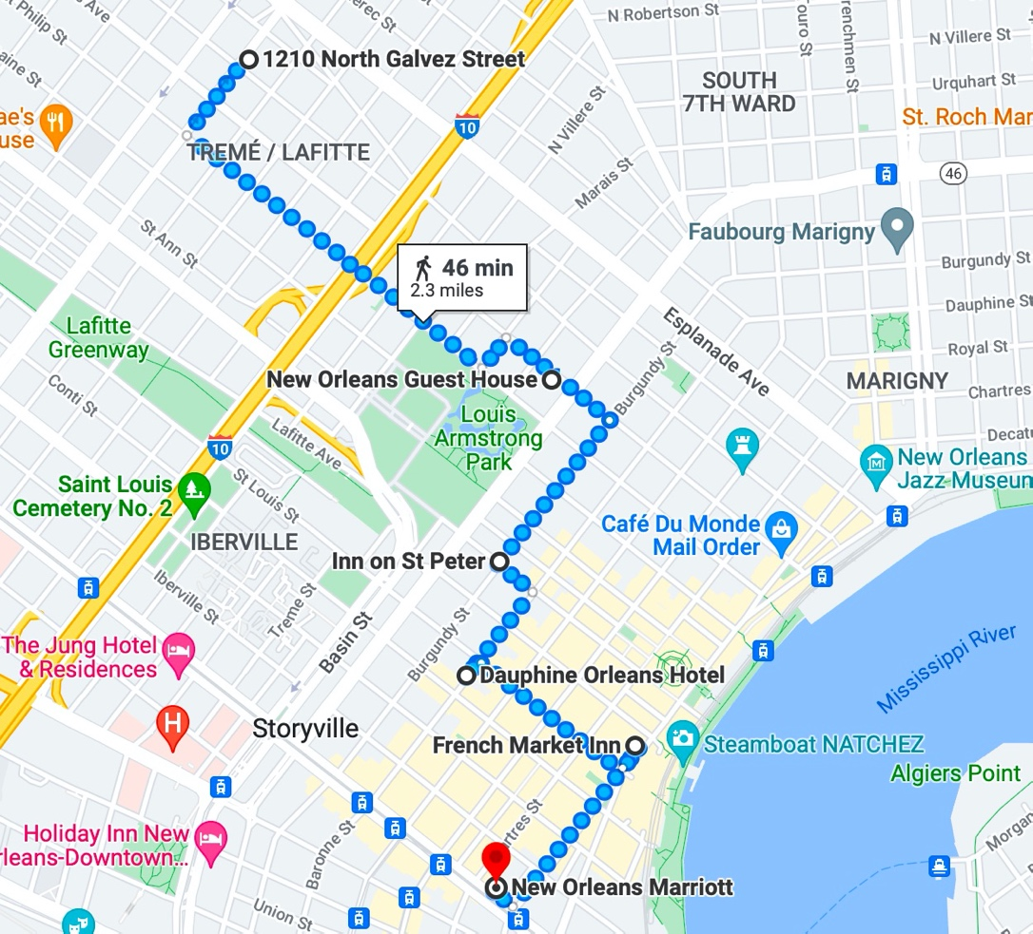
Mary & Jim
Patty
Michael

New Orleans Guest House
1118 Ursuline
Ron
Rosie

Inn on St. Peter
1005 St. Peter
Vanessa & Joel

Dauphine Orleans
415 Dauphine
Ellen
Mo
Kari & Scott

French Market in
509 Decatur
Elma
Erin

Marriott
555 Canal St.
Marlee & Neil

